A New Analysis for Charollais Sheep
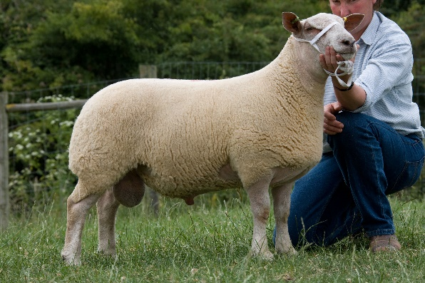
The Charollais breed has made tremendous genetic progress since flock recording began in the 1980’s.

Signet’s recording service has changed over time with the incorporation of new traits and indexes, but the launch of the National Terminal Sire Evaluation in 2019, will be our biggest change yet.

In 2019 Signet will deliver a new multi-breed analysis, benefits include
- Monthly BLUP runs
- Enhanced, more commercially focussed carcase trait EBVs
- Eight new EBVs derived from CT scanning
- Rebasing EBVs to aid interpretation by commercial buyers

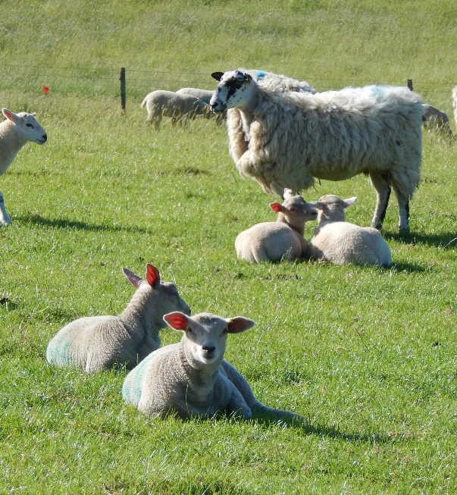
More commercially focussed carcase traits
Historically traits like muscle depth have been adjusted for age to identify lambs that lay down muscle at a certain age, regardless of weight.

Breeders can already select for growth rate, so a better approach is to assess muscling independently from growth i.e. a comparison of muscling/fatness at a fixed weight, rather than a fixed age.

Within the new evaluation all carcase trait EBVs will be weight adjusted, rather than age adjusted. The new approach is advantageous for commercial producers as it enables them to optimise muscling and finish when lambs are drawn at a fixed weight.

New EBVs from Computed Tomography (CT)
Over the last 15 years over 10,000 lambs have been CT scanned and additional measures collected. Within the new evaluations, EBVs will be produced for spine traits (length and vertebra number), muscle area and predicted intramuscular fat (IMF)

EBVs rebased to aid interpretation
All Estimated Breeding Values are being reset to a 2010 base, making EBV interpretation both easier and more relevant to commercial ram buyers.

Commercial producers buying high EBV Charollais rams can lift profitability by £4 per lamb. A benefit worth an extra £1,000 over their lifetime
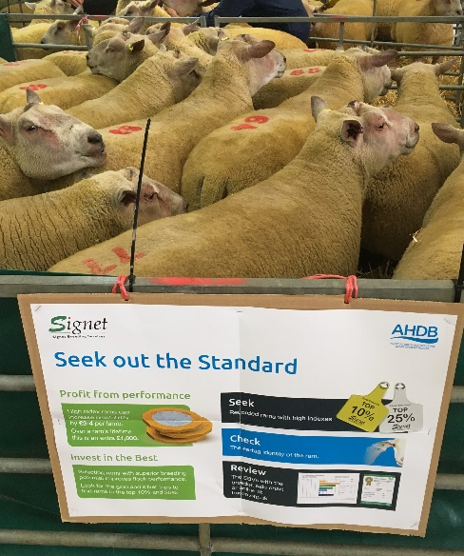
Why Record my Charollais Flock?
Signet recording adds value to pedigree flocks
- Greater interest from commercial buyers
  - Add value to ram sales and increase clearance rates
  - Create marketing information to promote elite genetics

- Improve breeding decisions and the sheep in your flock
  - Rank individuals in your flock against the breed

If you want to take your flock forward, add value to your breeding stock and promote your genetics, then start recording with Signet

What does it cost to record with Signet?

Flock recording fees for the coming year:
 | Paper | Online / electronic
Flock fee | £120 | £95
 | Additional £/ewe
First 50 ewes | £3.00 | £2.50
51-150 ewes | £3.00 | £2.00
151-400 ewes | £3.00 | £1.00
401+ ewes | £3.00 | £0.50

• Flocks outside Great Britain are required to pay an additional £95/flock genetic evaluation fee
• Fees quoted here are exclusive of VAT. Full fee information provided on application
• Ultrasound scanning services are charged separately. Typically, £175/visit for 100 lambs.

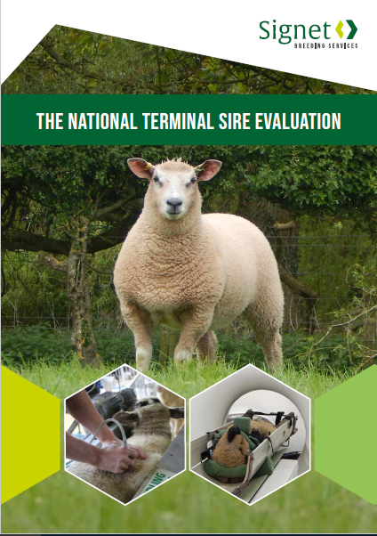
How can I get involved?
Signet offers online recording services, so getting started has never been easier and costs are ~£50-100/flock less than three years ago.
Flocks considering recording their flock can contact Signet directly for a starter pack. Email: signet@ahdb.org.uk Tel: 0247 647 8829

A more informative, more frequent and more commercially focussed breeding evaluation from Signet Breeding Services

