Genetic gain in Signet Recorded Flocks – Samuel Boon, 2nd April 2020
Genetic gain has markedly increased in the last 5 years according to a recent review of genetic progress within Signet’s sheep breeding programmes. Major improvement has been observed in each of the breed types recorded through Signet; namely the terminal sires, lowland maternal breeds and hill sheep.
Within Terminal Sire breeds, recent genetic gain has been particularly fast – as breeders change their breeding policies to place more emphasis on breeding lines that not only grow quickly, but also have a superior yield of meat in the carcase. Here ram breeders have been aided by Signet’s introduction of new, weight adjusted breeding values for carcase traits – as well as levy board support for measurement services like CT scanning.
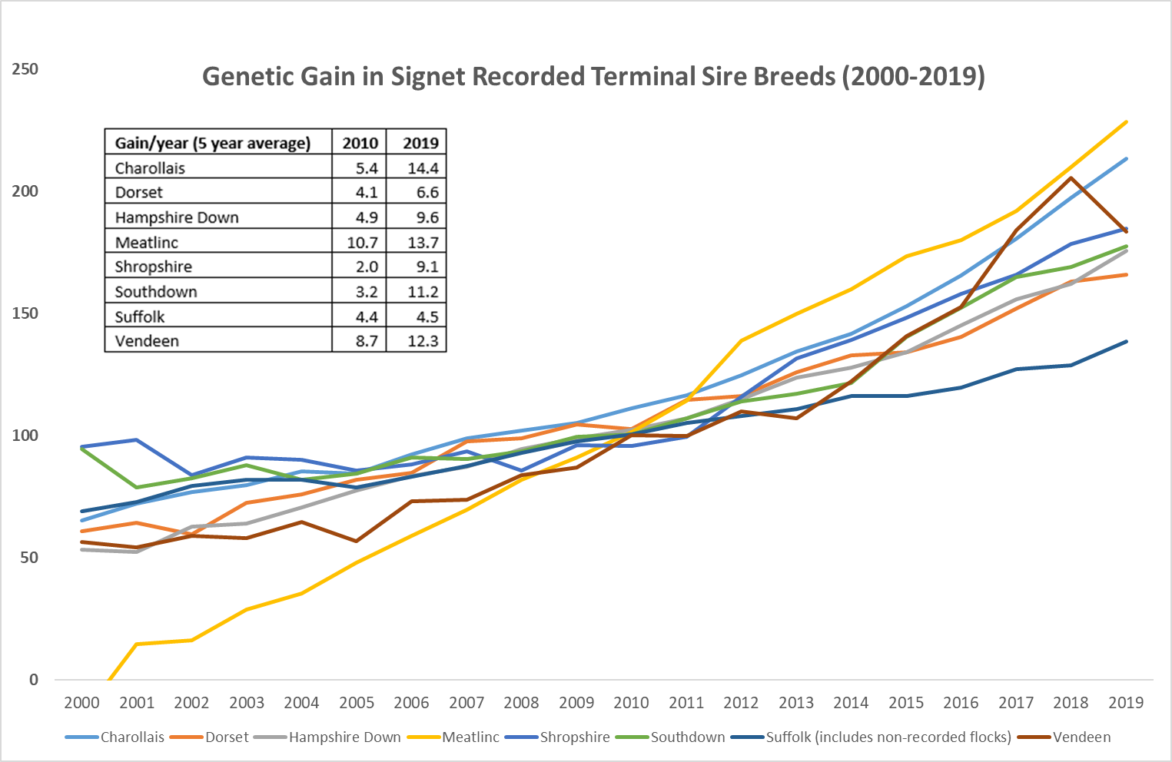
Maternal breeding programmes have also made faster progress in recent years, as producers place more emphasis on economically important EBVs like prolificacy and maternal ability. The Lleyn is by far the most widely recorded maternal breed, with between 15,000 and 20,000 lambs recorded per year over the last decade. However, even relatively new breeding lines like the Exlana, a wool shedding composite, have made rapid progress using performance records to select superior breeding stock right from their launch.
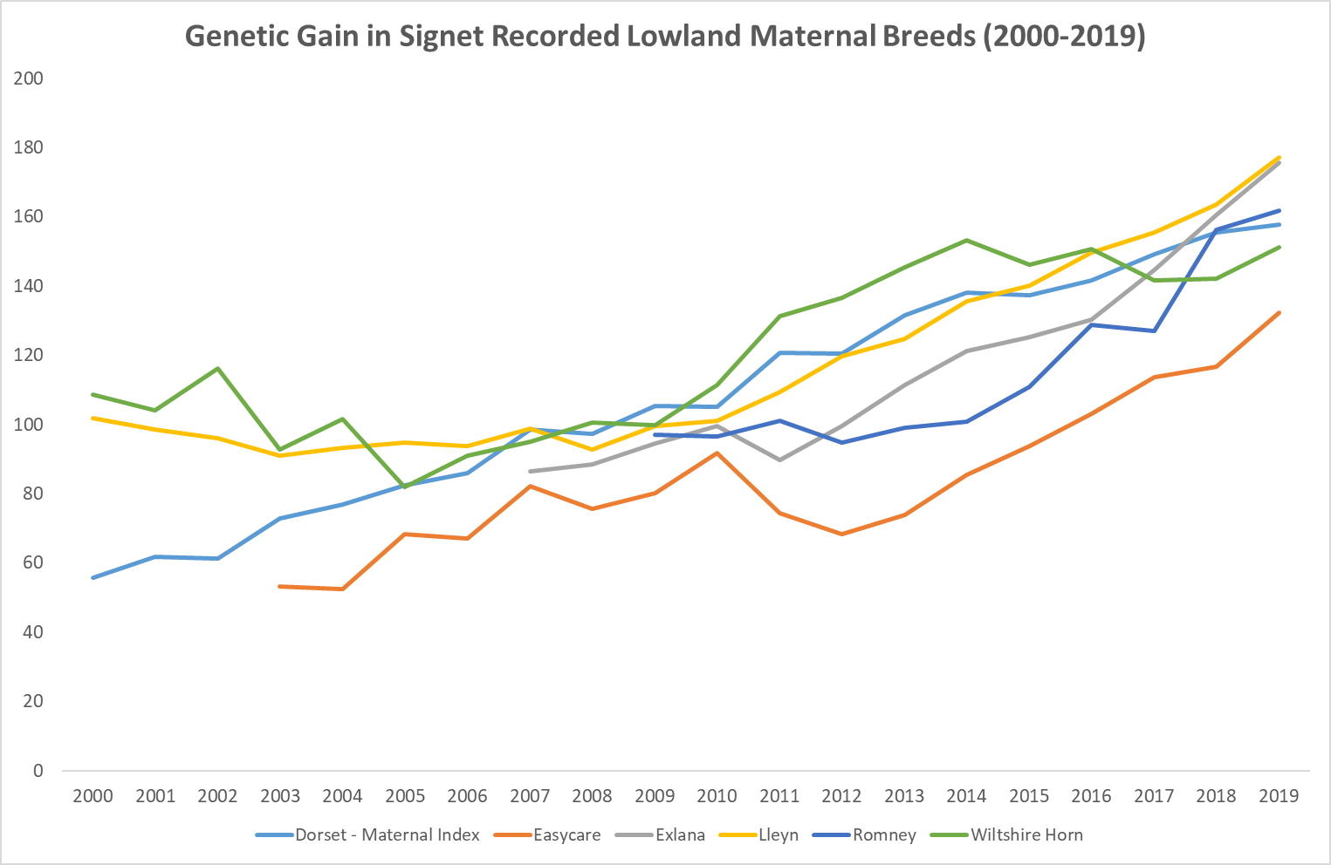
It is 50 years this month since the first hill sheep were born and later weight recorded in what was to become Signet’s hill sheep breeding evaluation. Progress within the hill sector is always more challenging; data collection on the hill is more difficult and ram breeders have a wide range of traits to take into consideration when selecting breeding stock.
Even so, the trends observed within those flocks that record with Signet show what can be achieved through careful selection. High gains are being achieved within Beulah and Scottish Blackface breeding programmes and last year the number of Welsh Mountain lambs recorded with Signet nearly doubled, with further increases in recording numbers expected in 2021 as part of a breeding project run by HCC. This explains the current plateau in the Welsh Mountain genetic trend, but also the potential to come. 